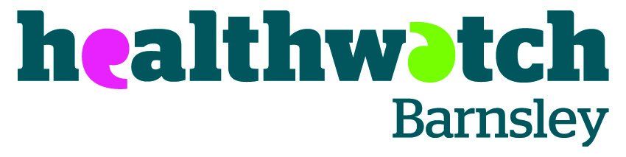
Meeting: | Healthwatch Barnsley Shadow Board
Date: | 17 January 2014
Location: | The Core, County Way, Barnsley
Chair: | Nigel Middlehurst
In attendance:  Nigel Middlehurst  Ann Moffatt  Carolyn Ellis (minutes)  Present:  Irina Sidorova  Tony Alcock  Adrian England  Margaret Baker  Anthony Murray |  | Apologies:  There were no apologies
Apologies / Declarations of interest (pecuniary and non-pecuniary) |  |  | Action by
Nigel welcomed everyone to the meeting. There were no apologies.  Anthony Murray and Adrian England confirmed that they had returned their forms relating to declarations of interest. Tony Alcock said he has completed his form and will return it to the next meeting. |  |  | Tony Alcock to return his form.
Minutes of the previous meeting / Actions from previous meeting |  |  | Action by
Nigel Middlehurst gave an update about the Healthwatch budget for the next financial year. He informed the group that there is a verbal agreement that the budget for 2014/15 should remain approximately the same, but that there may be a slight decrease.

Nigel could not confirm what a ‘slight decrease’ would mean in real terms and that the Shadow Board would be informed as soon as Voluntary Action Barnsley (as the current contract holders) were made aware.

Adrian England asked that the minutes be amended on page 3 to include the point that the Shadow Board agreed that an advertisement will be designed to increase the number of people on the Shadow Board, including a Chair.

Nigel Middlehurst confirmed that the item regarding signposting raised in the previous minutes under ‘any other business’ has been raised at the Health and Wellbeing Board to seek other opinions about this point. Especially if a provider that has received feedback is the only provider of that service in Barnsley.
Future of Healthwatch Barnsley |  |  | Action by
Nigel Middlehurst started the discussion by explaining that in the original contract it stated that Healthwatch Barnsley would a separate organisation.

Nationally, there is a move that a lot of Healthwatch organisations are based in, and continue to be based in, Voluntary Action organisations or even private sector organisations in some instances.

Nigel informed the meeting that there is a move within Healthwatch commissioners that the Healthwatch contract remains within the lead body, in this instance Voluntary Action Barnsley. Nigel said that Voluntary Action Barnsley does not seek to influence Healthwatch Barnsley and that Voluntary Action Barnsley’s trustees do not get involved with Healthwatch Barnsley activities.

Nigel went on to explain that Key Performance Indicators (KPIs) were already set before 1 April 2013 (when Healthwatch came into existence) but that there might be room for negotiation about the KPIs for the next financial year and that the Shadow Board members will be heavily involved with outputs and outcomes setting.

Adrian England stated that the next year is crucial to meet and exceed targets, especially when Healthwatch’s performance goes to the Scrutiny Panel.

Margaret Baker told the group that she has heard criticism about Healthwatch in meetings and so it is vital that Healthwatch works.

Conversations then took place about sustainability of Healthwatch Barnsley and the possibility of making money around health and social care. Adrian England pointed out that potentially money could be made from enter and view inspection visits in the future.

The group also discussed the importance of maintaining the relationship between Healthwatch Barnsley and other regional Healthwatch organisations as there may be options in the future to deliver contracts regionally.

Nigel then introduced Ann Moffatt to the meeting. Ann handed out information to the group about the possible models that Healthwatch Barnsley could take to become an independent organisation. Ann also handed out a skills audit to the group that she thought may be of use when they recruit more Shadow Board Members. All information that Ann handed out as available as an appendix to these minutes.

Nigel thanked Ann for attending and presenting the information to the group. He then suggested that the group remain in the room following the meeting to discuss their options and a way forward.
Any other business |  |  | Action by
None.
Date and time of next meetings |  |  | Action by
Future meeting dates are as follows:

Steering Group – 5 February 2014 at 2pm in the Conference Room at The Core

Shadow Board – 10 February 2014 at 2pm in the Training Room at The Core.
Discussion about the way forward |  |  | Action by
Nigel Middlehurst and Ann Moffatt left the meeting and the Shadow Board members had a conversation about the way forward for Healthwatch Barnsley.  Anthony Murray pointed out that the group needed to decide one option from four which are:  - Continue as is  - Become a Charitable Incorporated Organisation  - Become a Company Limited by Guarantee  - Become a Cooperative.  Anthony pointed out that option four was not possible so the group needed to agree how to proceed.  Currently the Shadow Board members feel that the board needs more members and a Chair in order to move forward.  The group decided that they would stay with Voluntary Action Barnsley for the next 12 months with a view to working towards independence in the next year.  The Shadow Board acknowledged that there needs to be a lot of work in the next 12 months to prepare for independence.  The Shadow Board decided that they also need to get more involved with Healthwatch Barnsley and the work that the staff team are updating |  |  | Shadow Board members to look at policies and procedures to work towards independence and speak to Carrianne Stones about greater involvement in activity.

